DBQ Focus #3: WAR THAT TURNS THE TIDE – The French and Indian War 1754-63
Name: Date: Class:

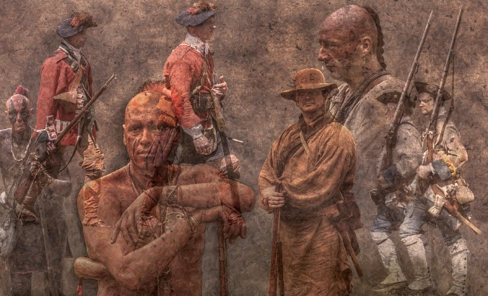
Document-Based Question Format: The following question is based on the accompanying Documents (the documents have been edited for the purpose of this exercise.) This question is designed to test your ability to work with and understand historical documents.
Write a response that:
- Has a relevant thesis (claim) and supports that thesis with evidence (Concrete Detail) from the documents.
- Cites evidence from included source perspectives.
- Has evidence (concrete details) and commentary analysis that follows the Jane Schaffer writing method.
- Analyzes the documents by grouping them in as many appropriate was as possible. Does not simply summarize the documents individually.
- Takes into account both the sources of the documents and the author’s points of view.
- Uses MLA Format
Historical Context: The decade leading up to the outbreak of the French and Indian War (1754-63), known in Europe as the Seven Years’ War, saw conflict on the British-French frontiers in New England, New York, and Nova Scotia, all of which were well populated with Indigenous villages of various nations as well as French Settlers called Acadians. A class of interests among British settlers, Indigenous communities, and Acadians in the region of the present-day Canadian Maritime Provinces led to a four-year conflict that the British called King George’s War. In negotiations to end the war, Britain did not insist on consideration for the Indigenous nations that resisted the settlers’ war of secession. In the resulting 1783 Treaty of Paris, the Crown transferred to the United States ownership of all its territory south of the Great Lakes, from the Mississippi to the Atlantic, and north of the Spanish-occupied Florida. Many Americans think of the Revolutionary War as the pivotal event of eighteenth-century America because, to them, it represents the beginnings of our country. However, some historians argue that the French and Indian War was more significant, as its events and aftermath started Americans on the path to independence.

Question: What is your analysis of the state of “Indian Country” as European Settler’s vie for Indigenous lands and what is the impact of the French and Indian War on Indigenous peoples?
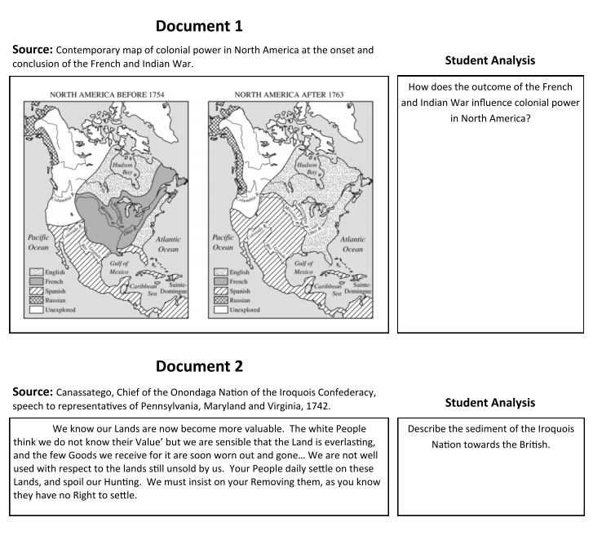
Document 3
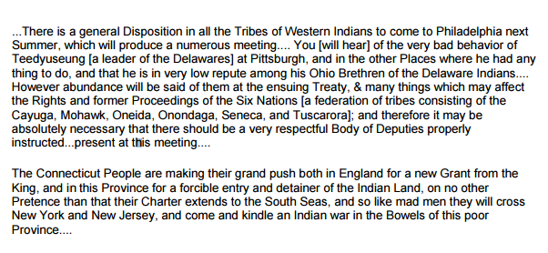
Source: The Fate of Native Americans, letter by Richard Peters, 1761. Student Analysis
What are they expecting Teedyuseung to do at the meeting in Philidelphia and what do they plan to do in return?

Explain what the Connecticut People are trying to do and what they think will happen as a result.

Document 4
Source: Scarrooyady, an Iroquois leader, at a 1753 treaty Student Analysis
Your traders now bring us scare any Thing but Rum and Flour. They bring us little Powder and Lead, or other valuable Goods. The rum ruins us. We beg you would prevent its coming in such Quantities, by regulating the Traders. . . . We desire it be forbidden, and none sold in the Indian Country.
How is alcohol being used as a weapon against Indigenous people?

Document 5
Source: Sir Jeffery Amherst, commander of British forces in North America, July 7, 1763
Student Analysis
What tactic is being used to wipe out Indigenous peoples?
"Could it not be contrived to Send the Small Pox among those Disaffected Tribes of Indians? We must, on this occasion, Use Every Stratagem in our power to Reduce them." He ordered the extirpation of the Indians and said no prisoners should be taken. About a week later, he wrote to Bouquet: "You will Do well to try to Innoculate the Indians by means of Blanketts as well as to try Every other method that can serve to Extirpate this Execrable Race."

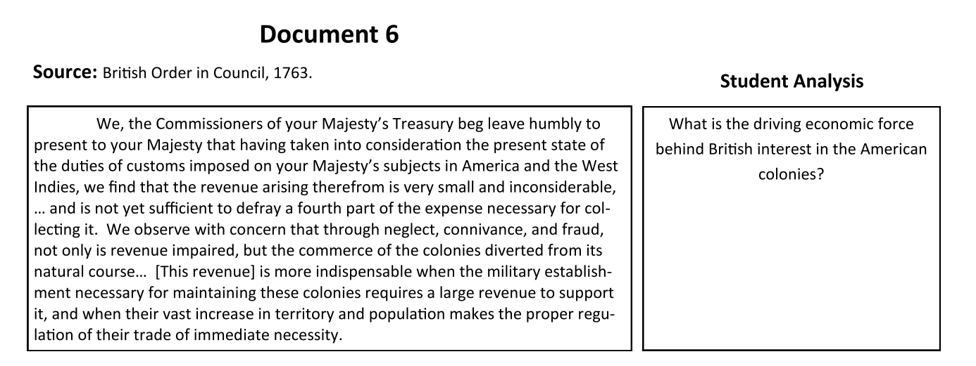

Document 7
Source: Benjamin Franklin on the Iroquois League, in a letter to James Parker, 1751.
Student Analysis

It would be a strange thing if Six Nations of ignorant savages should be capable of forming a scheme for such an union, and be able to execute it in such a manner as that it has subsisted ages and appears indissoluble; and yet that a like union should be impracticable for ten or a dozen English colonies, to whom it is more necessary and must be more advantageous, and who cannot be supposed to want an equal understanding of their interests.

What is Benjamin Franklin saying about the Iroquois League?

Document 8
Source: Pontiac, an Ottawa chief, voicing the proclamations of the “Master of Life,” 1763
I am the Master of Life, whom thou desirest to know and to whom thou wouldst speak. Listen well to what I am going to say to thee and all thy red brethren. I am he who made heaven and earth, the trees, lakes, rivers, all men, and all that thou seest, and all that thou hast seen on earth. Because . . . I love you, you must do what I say and [not do] what I hate. I do not like that you drink until you lose your reason, as you do; or that you fight with each other; or that you take two wives, or run after the wives of others; you do not well; I hate that. You must have but one wife, and keep her until death. When you are going to war, you juggle, join the medicine dance, and believe that I am speaking. You are mistaken, it is to Manitou to whom you speak; he is a bad spirit who whispers to you nothing but evil, and to whom you listen because you do not know me well. This land, where you live, I have made for you and not for others. How comes it that you suffer the whites on your lands? Can you not do without them? I know that those whom you call the children of your Great Father supply your wants, but if you were not bad, as you are, you would well do without them. You might live wholly as you did before you knew them. Before those whom you call your brothers come on your lands, did you not live by bow and arrow? You had no need of gun nor powder, nor the rest of their things, and nevertheless you caught animals to live and clothe yourselves with their skins, but when I saw that you inclined to the evil, I called back the animals into the depths of the woods, so that you had need of your brothers to have your wants supplied and I shall send back to you the animals to live on. I do not forbid you, for all that, to suffer amongst you the children of your father. I love them, they know me and pray to me, and I give them their necessities and all that they bring to you, but as regards those who have come to trouble your country, drive them out, make war on them. I love them not, they know me not, they are my enemies and the enemies of your brothers. Send them back to the country which I made for them. There let them remain.

Student Analysis
What is Pontiac asking?
Document 9

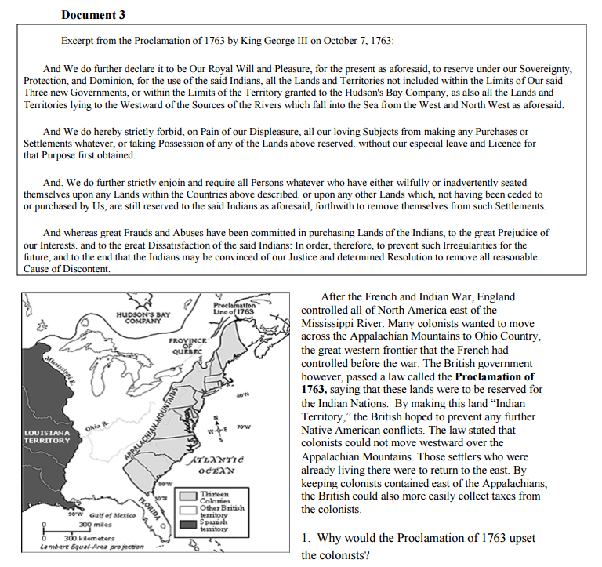

Student Analysis:
Why would the Proclamation of 1763 upset the colonists?

How would the Proclamation of 1763 please the Indigenous Peoples?

How could the Proclamation of 1763 be viewed as a cause of the American Revolution?

Document 10

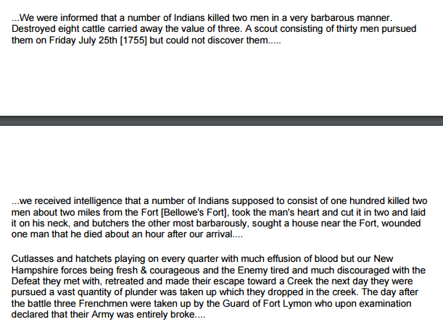

Student Analysis:
To what does Moses attribute their success against the French?

Document 11

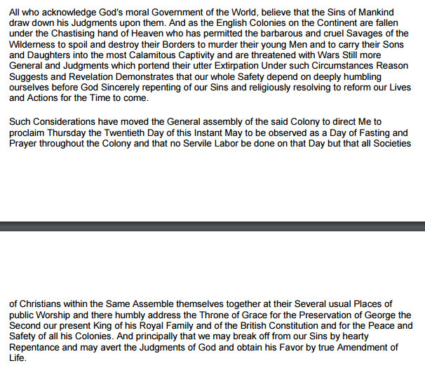

Student Analysis:
Describe why Hopkins has made this proclamation.

What result does he hope to obtain?

Document 12

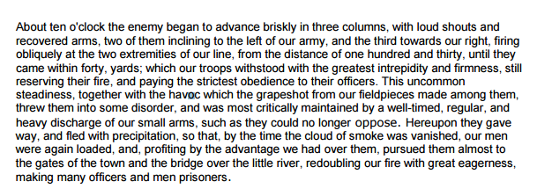
Student Analysis:
To what does Knox attribute the victory?

Document 13

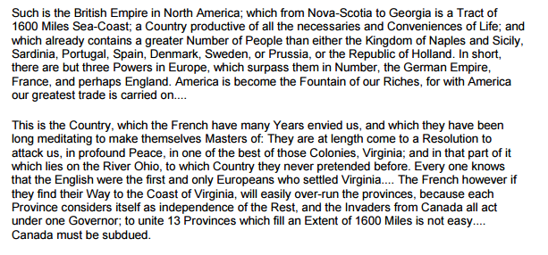
Student Analysis:
Why are the French envious of Britain?
Why is the 1600 mile tract important?

