The Native American Community Academy (NACA) Story
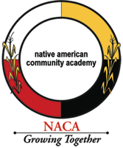
Albuquerque, New Mexico, Grades 6-12, expanding to K-1 in Fall 2016
NACA Mission: To engage students, educators, families, and community in creating a school that will prepare our students to grow from adolescence to adulthood and begin strengthening communities by developing strong leaders who are academically prepared, secure in their identity and healthy.
Native American Community Academy (NACA) is a tuition-free public charter school for grades 6-12 located in Albuquerque, New Mexico. Since its founding in 2006, NACA has been guided by the belief that Native American children thrive in academic environments that include and value their language, history, heritage, and culture. With almost 400 students, 95% of whom are Native American, 87% qualifying for free and reduced price lunch, NACA captures almost 15% of the Native American student demographic in the Albuquerque Public School District for grades 6-12. It is the only urban charter school dedicated to Native American student success in the state. Students represent more than 60 tribes, and teachers and administration also reflect this diversity. Approximately 65% of teachers are Native American.

NACA received New Mexico’s highest rating for student growth in 2012–13, outperforming the state average for improving academic achievement.
A
100
100 percent of NACA seniors are accepted into college.

Of graduating seniors, 83 percent have gone on to college immediately after their Senior year. This is four times the national average for Native students.
A
4x

NACA received an A in College and Career Readiness on the NM report card.

Historically, Native American youth face some of the poorest educational outcomes in the nation, with students dropping out of high school at twice the national rate. They are the only racial group with no appreciable gains in reading or math since No Child Left Behind was implemented in 2001.
NACA provides a quality education that is an alternative to historically troubling statistics, and is transforming Native American education so that it is both excellent and relevant, pushing our youth to succeed as the next generation of Native American leaders. NACA seeks to empower its students to overcome obstacles that have traditionally held Native students back from reaching their full potential. Social isolation, historical trauma, loss of cultural identity, and few quality school options have led to increased risk for poor academic, health, and social outcomes. At our community-designed and Native-led school, NACA students are beating the odds: they are achieving at rates better than the average New Mexico Native American student; the vast majority are entering college; and they are emerging as Native leaders empowered by cultural awareness. NACA succeeds because it offers a personally relevant education grounded in cultural and traditional ways of learning, while aligning curriculum with Common Core State Standards and emphasizing academic excellence.

APPROACH: NACA’s unique curriculum has channeled traditional Native learning to offer students a highly personalized education in a nurturing environment. The school’s approach combines traditional and contemporary ways of learning and engages students, peers, community members, and families in planning and assessment and ongoing student success.

- NACA Teachers participate in 254 hours of PD annually.
- NACA currently offers five languages, including four Native languages (Lakota, Navajo, Keres, and Tiwa), which students can take for “foreign” language credit. NACA recognizes that due to the influence of Western assimilation-based educational models that it is imperative NACA students rebuild their language and culture.
- Approximately 70% of the student body is enrolled in a Native language class in middle school, and 100% of high school students complete 2-4 years of language studies.
NACA uses a Wellness Wheel as a tool for checking in with students. Each student works with a counselor to assess his or her personal wellness across the four areas of the Wheel—Intellectual, Physical, Social/Emotional, and Community/Relationship. Student-led parent/teacher conferences include time exploring the Wellness Wheel.
- The curricula are hands-on, using a highly-engaging and culturally rich and relevant approach to motivate youth.
- NACA uses a variety of methods and venues including the classroom, out-of-school-time learning, enrichment trips, and presentations to enhance student learning.
- NACA engages parents through community activities and and a monthly Indigenous language and cultural celebration night.

Community partnerships strengthen NACA’s efforts. Community events at NACA include quarterly student-led conferences, feast day, NACA pageant, piñon picking, Native pride week, school dances, Indigenous Language night, Thanksgiving meal, Winter Carnival, Grocery Bingo, NACA radical poetry and NACA Rock performances, NACA pow-wow, among many others. Investments from national funders bring to bear the financial resources necessary to tailor educational opportunities to the needs of Native students and to grow opportunities for Native American educators and innovation.

Furthering Student Success: As an award-winning and high-performing charter school, NACA offers a replicable model that is part of the solution to remedying long-standing educational inequities in Native American education. Through its new initiative called the NACA-Inspired Schools Network (NISN), Fellows are learning to replicate NACA’s successful programming to create schools of excellence and relevance for Native American students.

Contact Information:
1000 Indian School Rd NW
Albuquerque, NM 87104
(505) 266-0992
www.nacainspiredschoolsnetwork.org
www.nacaschool.org

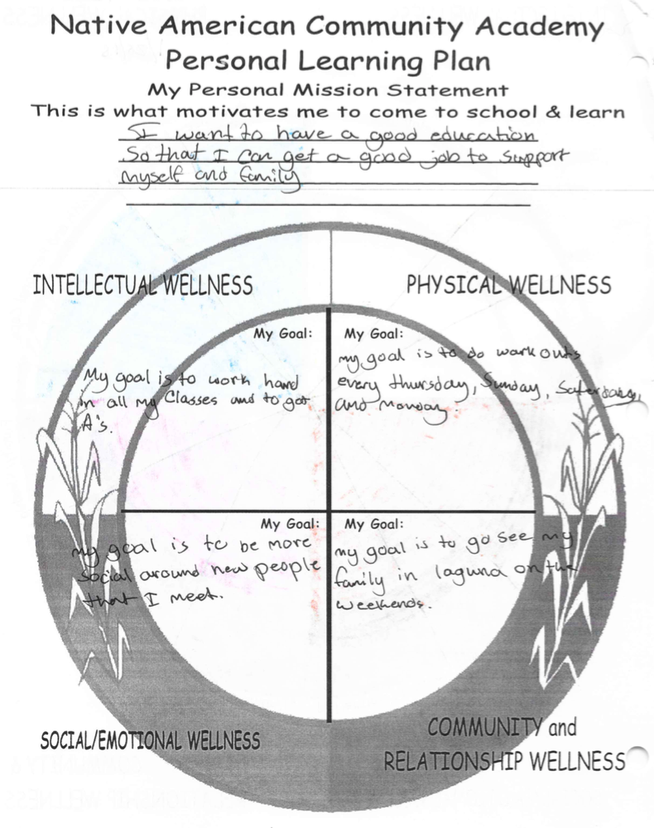
(Front and back). A blank version is available on our website.
Student Samples of completed Wellness Wheels
